**Exercise 1**

What is the object-oriented example?  
For example, say we created a class, Car, to contain all the properties a car must have, color, brand, and model. We then create an instance/behavior/method of a Car type object, myCar to represent my specific car.  
Could you please create another 5 object-oriented examples and give all their properties and their instances/behavior/method?

1. **Bird**

Type :

Eagle

Feathers : Yes

Size : Medium

Number of Legs : 2

Type :

Ostrich

Feathers : Yes

Size : Large

Number of Legs :

2

4. Size

Type :

Hummingbirds

Feathers : Yes

Size : Small

Number of Legs : 2

Properties:

1. Type

2. Feathers

3. Size

4. Number of Legs

Behaviour:

1. Eat()

2. Sleep()

3. Lay eggs()

4. Eat()

Class:  
Bird

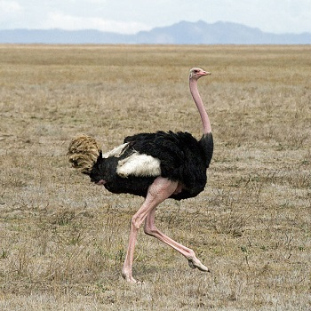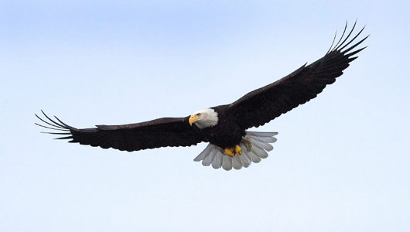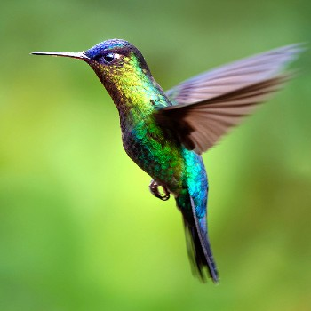

1. **Laptop**

Model : Acer Nitro 5

Operating System :

Windows 10

Storage : 256 GB

Processor : Intel Core i7

Model : Lenovo ThinkPad L490

Operating System :

Windows 10

Storage : 512 GB

Processor : Intel Core i5

Model : MacBook Pro

Operating System :

macOS Catalina

Storage : 256 GB

Processor : Intel Core i5

Behaviour:

1. Type messages()

2. Stream videos()

3. Screen Recording()

4. Eat()

Properties:

1. Model

2. Operating System

3. Storage

4. Processor

4. Size

Class:  
Laptop





1. **Fish**

Type : Whale

Size : Large

Blood : Warm-Blooded

Number of fins : 4

1. Type : Sardine

2. Size : Small

3. Blood : Cold-Blooded

4. Number of fins : 5

Type : Salmon

Size : Medium

Blood : Cold-Blooded

Number of fins : 8

Behaviour:

1. Swim()

2. Eat()

3. Breath()

4. Eat()

Properties:

1. Type

2. Size

3. Blood

4. Number of fins

4. Size

Class:  
Fish

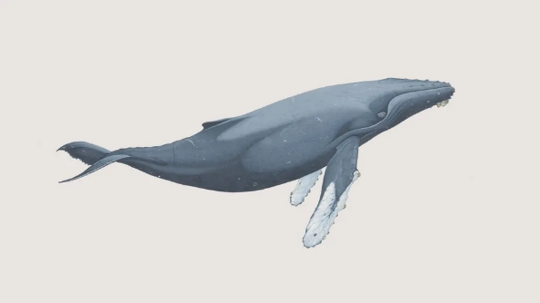

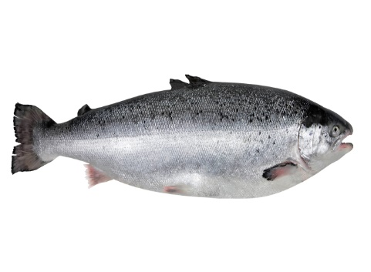

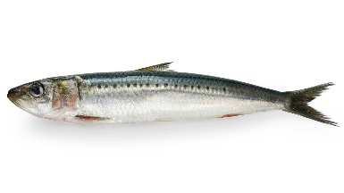

1. **Horse**

Breed : Morgan

Colour : Dark Brown

Weight : 950 ~1,100 pounds

Height : 56 ~ 60 inches

Breed : Appaloosa

Colour : Colourful Coat Pattern

Weight : 950 ~1,200 pounds

Height : 56 ~ 60 inches

Breed : Arabian

Colour : White

Weight : 800 ~1,000 pounds

Height : 56 ~ 64 inches

Behaviour:

1. Walk()

2. Eat()

3. Breath()

4. Eat()

Properties:

1. Breed

2. Colour

3. Weight

4. Height

4. Size

Class:  
Horse

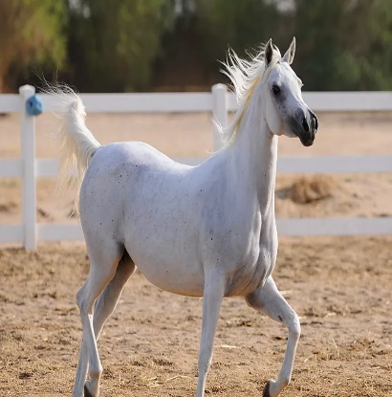

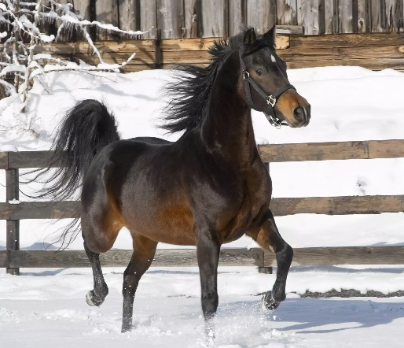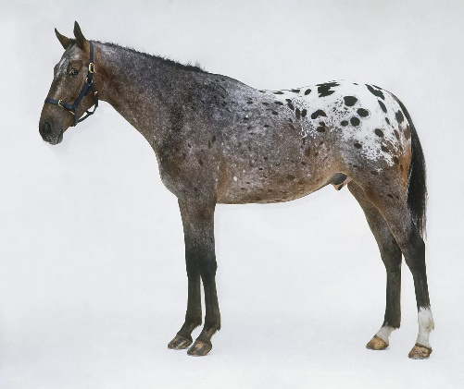

1. **Insect**

Type : Mantis

Colour : Mostly Green

Number Of Legs : 6

Skeleton : Exoskeleton

Type : Ant

Colour : Red Or Black

Number Of Legs : 6

Skeleton : Exoskeleton

Type : Ladybug

Colour : Colourful

Number Of Legs : 6

Skeleton : Exoskeleton

Behaviour:

1. Walk()

2. Eat()

3. Breath()

4. Eat()

Properties:

1. Type

2. Colour

3. Number Of Legs

4. Skeleton

4. Size

Class:  
Insect

